

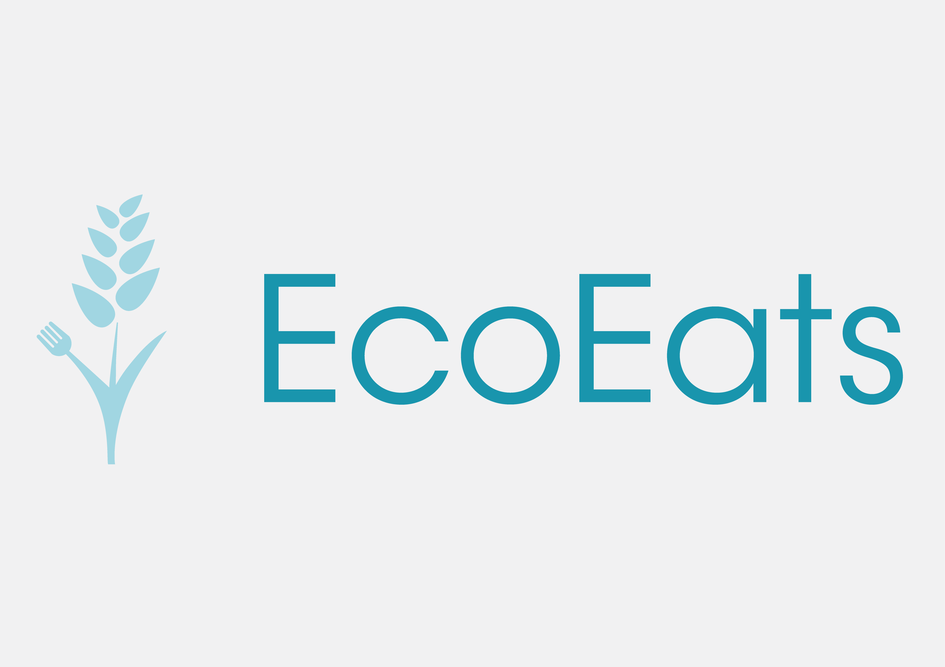

# Business Plan

Signe Anderson, Leo Chai, Amey Dhamgunde, Nilufar Jahandardoost, Surya Jain, Kelly Wong

2019/7/20

# Executive Summary

EcoEats is a company that aims to decrease packaging waste and food waste caused by impulsive purchases in grocery stores. We are creating an app that helps people organize grocery lists by compiling ingredients from the user’s appetite and suggesting the healthiest, environmentally conscious options.

We will start making an impact beginning from the launch date of our app on August 24th, and it will offer environmentally conscious suggestions to allow people to become more aware of how much waste they generate. While the impact will be small at the initial release of the app, we plan for a large increase in downloads as the app, and the methods of promotion, such as ads, begin to circulate on different platforms.  We are planning to reach this goal by including a large number of keywords, and by creating promotional pictures and videos to make our app stand out from other apps.

Our solution to the growing problem of food waste will be an app that will provide users with more environmentally conscious options for their grocery purchases, while maintaining convenience for the regular grocery shopper. This app will allow the user to choose a desired meal, and search up packaging information about any of the ingredients. The app also allows the user to create their own shopping list, and add any products they wish. Our app will also be able to scan barcodes on different products and provide the user with information relating to the product, such as its carbon footprint, its packaging, cost and many other factors.

# Business Overview

## Description

### Problem

58% of food produced in Canada are wasted. Out of these wasted foods, about one third of it is still in unused condition, and can be sent to food banks to help those in need. One of the largest causes of the food waste is the purchase of extra food in grocery stores, especially when there is a sale (A. Janus, 2019). According to a draft report by the Ontario-based Value Chain Management Centre, 51 percent of the $27 billion of food wasted in Canada are leftovers thrown into trash bins. Spontaneous buying is a major contributor to this alarmingly high number, as many people see things they don’t need on sale at the store, and buy them anyway (M. Curtin, 2018). Many grocery stores are organized in a way that encourages shoppers to buy things that they don’t actually need by putting the most expensive, appealing items at eye level, where they are easy to spot (R. Rupp, 2015).

Aside from the amount of food waste generated in Canada, the excess amount of packaging that is applied to most food products is also a major concern. Food products usually have 3 layers of plastic wrapping when it is produced in the factory - one layer to protect the product in the shipping process, one layer designed to be placed on the shelf and one layer for the consumer to take home. This has led to large amounts of plastic waste around the globe, a problem especially well illustrated in oceans (Government of Canada).

 Solution

Our solution to the major problems of food waste and overpackaging is a mobile app, titled EcoEats. This app aids the common grocery shopper in making more environmentally conscious decisions while shopping with regards to portion sizes, packaging information, and the subsequent impact on the environment.

To aid impulsive buyers in reducing how much food they buy, this application will allow users to create lists of groceries to keep them on track while shopping. By allowing the users of our app to create their own lists, we hope that they will adapt and follow the list, as organization is key when it comes to avoiding impulsive buying.

We will also have a feature that allows users to select pre-planned meals. We acknowledge that life is busy, and even the best of plans often goes awry. This feature allows the user to select a meal and add all the ingredients needed for that meal into a convenient shopping list, which the user can purchase when they go shopping. These ingredients will all be sourced to be as eco-friendly as possible. By encouraging meal planning, we reduce the overconsumption of food items, thus reducing food waste.

One of our app’s unique features is a barcode scanner, whose purpose is to give the shopper access to the packaging information of the item they wish to buy. By scanning the chosen item, information will be relayed to the customer, such as the material of the packaging, how it impacts the environment, as well as suggestions for other, more eco-friendly alternatives. Through the creation of this app, we hope to meaningfully influence our users’ daily lives by informing them about how their food choices impact the environment. We also aim to help our users become more cognizant of packaging details, and help them reduce waste generated by food packaging.

As an incentive for users to use the app on a daily basis, we will include a selection of coupons that can be used in the stores that we partner with to get discounts.

Through the implementation of the features described above, in the format of an iOS application, we hope to help influence the decisions people make when it comes to grocery shopping. By targeting our service at the consumer level, we hope to educate the general public and encourage Canadians to be more mindful while shopping for their food.

### Alternatives

Some alternatives simply include making a meal plan or shopping at environmentally friendly stores. Our plan is the best solution because it combines these alternatives together into a single app in order for easier management and implementation into one’s daily routine. People are beginning to become aware of the consequences our actions hold on this earth and so there are many more individuals who seek to fix this problem before it’s too late. Our app is able to enhance how people shop for groceries, while also reducing waste and helping the environment.

## Market

### Target Customer

Our target customers are grocery store shoppers, but more specifically millennials. Having millennials as our target customer is advantageous because it is shown that millennials use apps more than other generations. One in five millennial app users, or 21%, say they open any app more than 50 times a day, compared to 2% of baby boomers (R. Panko, 2018) Millennials also tend to show habits of impulsive buying. Impulsive buying is the buying of goods without planning to do so in advance, as a result of a sudden whim or impulse. A study focused around 2000 Canadians and their shopping habits revealed that 63% of Canadians have succumbed to impulse buying with each person spending approximately $73.81 on average. Yearly, that amounts to $8.8 billion spent solely because of a sudden urge that could easily be avoided (DAC, 2019). With this app, we will be able to appeal to these customers with our built-in feature of being able to easily create a grocery shopping list in order to reduce the number of Canadians affected by this issue. With this feature, it will allow the consumer to be organized, and know exactly what they need to buy, which will reduce the amount of time they would spend in a store. The length of time spent in a store directly correlates to the amount they buys, and the amount of money they spend (P. Kozicka, 2015)

### Competitors

While there are already grocery shopping apps available such as Grocery Pal and Out of Milk, these apps have very outdated designs, and poor user experience due to bugs and limited functionality. We will be providing a modern app with a clean and simple interface with the comfort of our customers at the top of our list of priorities. It will be available to download from the iOS app store for free.

Out of Milk allows users to search up different items and add them to a grocery list to improve the simplicity of grocery shopping. Our app will make the user experience even more comfortable by allowing the customers to simply search up their desired dishes, and the app will compile a list of ingredients to the grocery list. We will be recommending the most environmentally conscious choice to buy based on the food’s packaging and carbon footprint, but also providing various alternative locations and brand to meet the consumer’s needs.

Grocery Pal provides deals and coupons for grocery shoppers. It compares the prices of different grocery goods on a weekly basis to determine the best option for the consumers. While our app will favor good buys, its main focus will be on the waste produced. Our app is targeted towards those who want to help take action to save the environment, while Grocery Pal’s objective is only to help people save money when grocery shopping. We will also provide information of the product such as its production date, its packaging and its impact on the ecosystem to give our users an opportunity to make a better choice when purchasing their groceries.

# Organization Plans

## Marketing Plan

We would promote our business through advertisements on platforms such as Youtube. As the majority of Youtube’s users, millennials would be the target audience of these advertisements. They are also more likely to spend money on items if they know that the source is sustainable, according to a study conducted by Neilson, the global data analytics company (Nielsen, 2015). We also plan to partner with other businesses that share our company’s values and practices.

We would also create social media pages on platforms such as Instagram or Facebook to generate information and awareness. There are 3.499 billion active social media users (Brandwatch, 2019) and so promoting ourselves through these means would allow us to reach a larger population.

## Operation Plan

The day to day operation of our business will include customer service, increasing functionality of our program and possibly extending it to different platforms.

We will be monitoring comments on the iOS app store regarding our device. Our company values user feedback, as we strive to be as transparent and open with the public as possible. We value user input as valuable information since they report issues of the app, and also suggest features for us to include. This will be helpful for our company as these reviews will keep us competitive to our competitors and give us the opportunity to dominate the market of mobile grocery lists.

Our program team will be working to fix bugs and pushing updates of the app to add new features. This is important because the technology world undergoes changes quickly, and we need to keep up with the shifts in the market.

We are also planning to extend to other platforms such as Android and the web. The profits we make from the iOS app will be used form the development of the other platforms to reach more users.

## Financial Plan

We plan to generate revenue by allowing free users to access the app with ads to supplement our profit. These ads would be in partnership with grocery stores and other businesses that share our company’s core values. These partnerships would also be a source of revenue, as companies would pay us to endorse their business and products. This would be beneficial for companies that are eco-friendly, as more people are willing to support businesses that focus on sustainability (M. Curtin, 2018).

We would also offer a premium subscription for users who would pay a monthly fee to access the full extent of the application’s functions. These exclusive functions would include access to the full selection of pre-planned meals, the removal of advertisements, and

As our startup cost is relatively low, we would not have to generate large amounts of profit to break even.  

## Action Plan

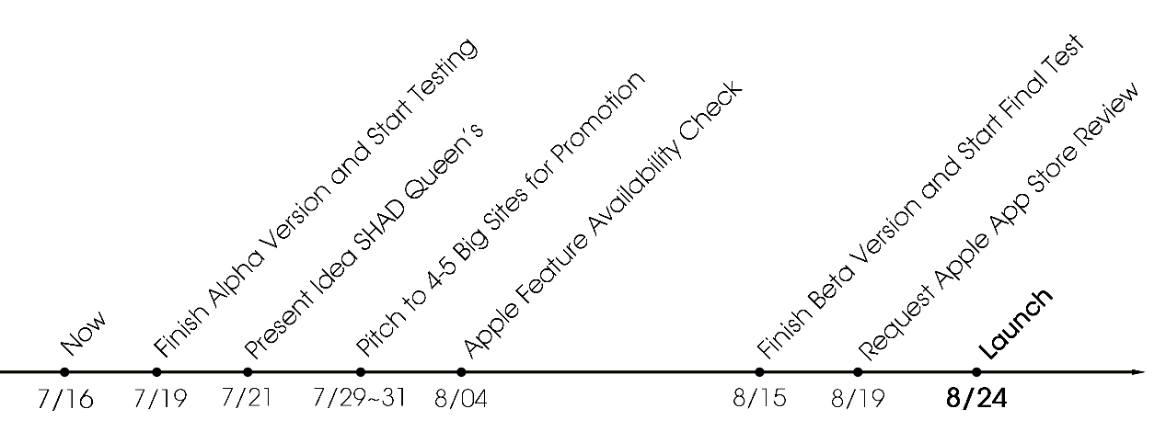

# Bibliography

"126 Amazing Social Media Statistics and Facts." Brandwatch. https://www.brandwatch.com/blog/amazing-social-media-statistics-and-facts/.

"App Launch Timeline." App Masters. January 16, 2017. https://appmasters.com/app-launch-timeline/.

Coughlin, Joseph. "Greener Than You: Boomers, Gen X & Millennials Score Themselves On The Environment." Forbes. May 07, 2018. https://www.forbes.com/sites/josephcoughlin/2018/05/05/greener-than-you-boomers-gen-x-millennials-score-themselves-on-the-environment/#1d4bff694d8b.

Curtin, Melanie. "73 Percent of Millennials Are Willing to Spend More Money on This 1 Type of Product." Inc.com. March 30, 2018. https://www.inc.com/melanie-curtin/73-percent-of-millennials-are-willing-to-spend-more-money-on-this-1-type-of-product.html.

"Green Generation: Millennials Say Sustainability Is a Shopping Priority." Nielsen. https://www.nielsen.com/eg/en/insights/article/2015/green-generation-millennials-say-sustainability-is-a-shopping-priority/.

Kemp, Simon. "Digital 2019: Global Digital Overview." DataReportal. January 30, 2019. https://datareportal.com/reports/digital-2019-global-digital-overview.

Kozicka, Patricia. "Psychology of an Impulse Buy: How Stores Manipulate You to Spend More." Global News. November 27, 2015. https://globalnews.ca/news/2365620/psychology-of-an-impulse-buy-how-stores-manipulate-you-to-spend-more/.

Kozicka, Patricia. "Psychology of an Impulse Buy: How Stores Manipulate You to Spend More." Global News. November 27, 2015. https://globalnews.ca/news/2365620/psychology-of-an-impulse-buy-how-stores-manipulate-you-to-spend-more/.

"More than Half of All Food Produced in Canada Is Lost or Wasted, Report Says | CBC News." CBCnews. January 17, 2019. https://www.cbc.ca/news/canada/toronto/food-waste-report-second-harvest-1.4981728.

Rupp, Rebecca. "Surviving the Sneaky Psychology of Supermarkets." National Geographic. January 23, 2018. https://www.nationalgeographic.com/people-and-culture/food/the-plate/2015/06/15/surviving-the-sneaky-psychology-of-supermarkets/.

"Sign the Petition." Home - Engaging Networks. https://act.greenpeace.org/page/36787/petition/1?locale=en-US.

"Survey Suggests Canadians Worried about Plastic Waste, Think Government Should Do More | CBC News." CBCnews. April 05, 2019. https://www.cbc.ca/news/business/marketplace-poll-on-plastics-1.5084301.

"Survey Suggests Canadians Worried about Plastic Waste, Think Government Should Do More | CBC News." CBCnews. April 05, 2019. https://www.cbc.ca/news/business/marketplace-poll-on-plastics-1.5084301.